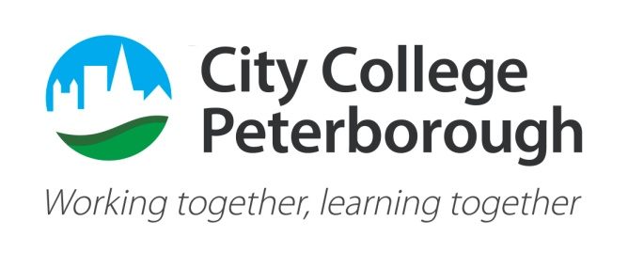 

**Environmental and Sustainability Policy**

**Position Statement**

City College Peterborough recognises that the earth is in a state of climate emergency and that all organisations and individuals impact on the environment in a variety of ways. As such, we are committed to the continual improvement of our environmental performance in relation to our services and operations and to manage our operations on a sustainable basis. Sustainability creates and maintains the conditions under which humans and nature can exist in productive harmony and that permit fulfilling the social, economic and other requirements of present and future generations.

The following is a quote by Hoesung Lee, chair of the IPCC (Intergovernmental Panel on Climate Change:

**“Every action matters**

**Every bit of warming matters**

**Every year matters**

**Every choice matters.”**

**Responsibilities**

This policy is the responsibility of all staff and sub-contractors. Relevant staff also have the responsibility to ensure that the spirit of the policy is adapted by all the people we serve and visitors through active participation and co-operation.

**Policy**

We are committed to ensure that we have and will continue to have, effective measures in place to reduce energy, waste, water, emissions and pollution to protect human health and our environment.

We also believe that we have the power to make a positive human impact on the diverse people we meet within the working environment. Our attention to environmental, social and economic responsibility includes working within the law in order to be innovative and demonstrate leadership on the issues that are important to us and our community.

As we promote and support environmentally friendly behaviour, we will ensure our actions and words build a better quality of life for our employees, learners, supported people, stakeholders, partners, suppliers and the wider community. In a teaching environment and considering the poor digital literacy of a number of our learners and supported people, we are unable to adopt a paperless policy. We will however, promote schemes to help to neutralise the impact we have on the planet through our paper consumption.

**Implementation**

We commit to:

1. Mapping our current provision against the United Nation’s Sustainable Development Goals and creating an action plan to help us to do more and to champion a culture of engagement with Education for Sustainable Development.
2. Increase cost-effectiveness by reducing our consumption of energy.
3. Minimise environmental impact in the areas of waste, water and energy.
4. Meet and where possible, exceed all environmental regulations relevant to our organisation and its activities.
5. Ensure sustainability when procuring goods and services, including minimising or preventing where possible, the purchase of single use items.
6. Give back to communities by being involved in charitable and community projects.
7. Promote education for sustainable development and practice through the college curricula.
8. Encourage sustainable travel practices by employees, learners and visitors, setting targets to maximise use of the electric car and bicycle.
9. Encourage and demonstrate sustainable approaches in the built environment in planning new facilities, refurbishments and maintenance projects. We commit to consider the environmental credentials of potential contractors as part of the tendering process.
10. Promote environmentally responsible behaviours throughout the City College Peterborough community.
11. Set, monitor and review relevant objectives and demonstrate continuous improvement.
12. Encourage staff involvement and ideas through the newsletter.

.

**Monitoring and Impact Assessment**

This policy will be reviewed annually, made available to the public via our website [www.citycollegepeterborough.ac.uk](http://www.citycollegepeterborough.ac.uk) and communicated to all employees and staff at the college. It will also be communicated to stakeholders, suppliers and partners.

**Document control sheet**

|  |  |
| --- | --- |
| Revision issue date: | **May 2024** |
| Next Review Due Date: | May 2025 |
| Date of most recent Equality Impact Assessment: | May 2024 |
| Document Lead and Author: | Adele Fender |
| Approvers and dates: | The Leadership Team – 10/06/24 |
| Purpose of the review: | Annual review |
| Dissemination: | Website and intranet |

This document can only be considered valid when viewed via the City College Peterborough internal web pages on the intranet. If this document is printed into hard copy or saved to another location, you must check that the version date on your copy matched that of the intranet version. The date will always appear on the footer.

|  |  |
| --- | --- |
| Revisions | |
| *May 23*  *May 24* | Additions:   * Included statement that the planet is in a state of climate emergency to the position statement. * Added IPCC Chair quote on Climate Change to position statement. * Added to Implementations no. 1 and expanded no. 5 to include restrictions on the purchase of single use items.   Additions:   * In a teaching environment and considering the poor digital literacy of a number of our learners and supported people, we are unable to adopt a paperless policy. We will however, promote schemes to help to neutralize the impact we have on the planet through our paper consumption.   Amendments: |