SAFEGUARDING &

CHILD PROTECTION POLICY

2025/26

Foreword

City College Peterborough has a statutory and moral duty to ensure that the College operates with a view to safeguarding and promoting the welfare of children and adults at risk. The College has a zero tolerance for abuse of any kind and other harmful behaviour affecting learners, supported people, or staff. Safeguarding is a priority at City College Peterborough.
All learners and supported people, regardless of age, disability, gender, racial heritage, religious belief, sexual orientation, or identity, have the right to equal protection from all types of harm and abuse. Peterborough City Council, along with all staff, including volunteers and agency staff working for the College, are responsible for the safety and welfare of children and adults at risk by following the procedures set out in this policy.
Safeguarding is a priority at City College Peterborough.

Contents
Foreword 1
1. Introduction 3
2. Objective 3
3. Responsibilities 3
3.1 Advisory Board 3
3.2 Designated Safeguarding Lead (DSL) 3
3.3 Deputy DSLs & Designated Persons 3
3.4 Executive Operations Manager 4
3.5 All College Staff 4
4. Definitions 4
5. Policy Statement 6
6. Records 7
7. Online Safety (Filtering & Monitoring) 8
8. Training & Preventative Education 8
9. Review 8
Document control 9
APPENDICES 9
APPENDIX 1: SAFEGUARDING PROCEDURES 10
APPENDIX 2 20
APPENDIX 3 – REFERENCES & MONITORING 22

Introduction

City College Peterborough places the highest importance on safeguarding; the safety and wellbeing of our college community is paramount in all activities. Our commitment applies to all staff, learners and people we support, subcontract partners and other college users; including volunteers, external contractors, remote learners, and employers where learners and people we support have work placements. Safeguarding is a priority at the College.
This policy sets out our commitment to safeguard and promote the wellbeing of children, young people and vulnerable adults across all provision. There are three main elements to our Safeguarding Policy: Prevention, Protection and Support.

Objective

Safeguarding and promoting the welfare of our learners and people we support is everyone’s responsibility. Everyone who comes into contact with learners and their families has a role to play. All staff take a person-centred approach and consider at all times what is in the best interests of the child. Early help is essential where problems emerge at home, online, and in college.

Responsibilities

3.1 Advisory Board
- Ensure all staff read Part One of KCSiE (or Annex A where appropriate).
- Receive annual safeguarding reports, including training compliance and trends.
- Ensure the IT system has appropriate filtering and monitoring in line with DfE standards, with an annual review and clear role assignment.
- Oversee liaison with social care regarding allegations against the Principal/DSL.
- Undertake appropriate safeguarding training.

3.2 Designated Safeguarding Lead (DSL)
- Lead safeguarding, child protection and Prevent strategy.
- Refer suspected abuse to social care and police; refer to Channel where appropriate.
- Ensure written records clearly capture concerns, actions, decisions, rationale and outcomes.
- Ensure child protection files transfer securely within 5 school/college days of transfer.
- Promote awareness of vulnerabilities (SEND, care leavers, children with a social worker etc).
- Ensure annual updates to safeguarding, Prevent, and online safety measures.

3.3 Deputy DSLs & Designated Persons
- Support the DSL; deputise as needed.
- Make referrals to social care/Channel; initiate multi-agency requests (MASH) where appropriate.
- Liaise with feeder schools and placement organisations to ensure safeguards.
- Maintain accurate records; update the DSL regularly; provide advice to staff.

3.4 Executive Operations Manager
- Audit safer recruitment checks (including online searches for shortlisted candidates) and DBS at correct levels.
- Manage allegations processes consistent with local and national guidance.
- Maintain records of staff understanding of KCSiE annual updates.
- Oversee the Single Central Record (SCR) for compliance.

3.5 All College Staff
- Create an ethos where learners feel secure, are encouraged to talk, and are listened to; take all reports seriously.
- Never make a child feel they are creating a problem or feel ashamed for reporting.
- Embed safeguarding content in curriculum/tutorials; promote equality and challenge extremism.
- Read KCSiE Part One (or Annex A as applicable) and follow this policy.
- Follow reporting procedures; record concerns on MyConcern.
- Recognise online risks and harms; respond to online abuse as seriously as offline abuse.
- Recognise heightened risks for SEND, LGBTQIA+, and gender questioning children; take a cautious, supportive approach.
- Understand and apply the College’s zero-tolerance stance on sexual violence/harassment.

Definitions

For the purposes of this policy, the following words and phrases have the meanings as indicated:
- Abuse & neglect: a form of maltreatment of a child. Somebody may abuse or neglect a child by inflicting harm or by failing to act to prevent harm. Harm can include ill treatment that is not physical as well as the impact of witnessing ill treatment of others. This can be particularly relevant, for example, in the impact on children in all forms of domestic abuse. Children may be abused in a family, in an institutional or community setting by those known to them or, more rarely, by others. Abuse can take place wholly online, or technology may be used to facilitate offline abuse. Children may be abused by an adult or adults or by another child or children. Abuse and neglect heading has been amended to include exploitation.
- “Child” or “Children” means a person(s) under the age of 18.
- “Channel” forms a key part of the Government Prevent Strategy (see below for Prevent definition). The process is a multi-agency approach to identify and provide support to individuals who are at risk of being drawn into terrorism and extremism.
- “College premises” means all buildings and land owned or operated by the college.
- “College staff” means all college employees, authorised agency staff and volunteers working on behalf of the college.
- Unexplained and/or persistent absence has replaced the previous wording of deliberately missing education and should always be considered a potential safeguarding concern.
- “Extremism” is defined in the 2011 Prevent Strategy as vocal or active opposition to fundamental British values including democracy, the rule of law, individual liberty, mutual respect and tolerance of different faiths and beliefs. Also included in the definition is extremism calls for the death of members of the UK armed forces, whether in this country or abroad.
- “Prevent” refers to the Prevent Strategy, published by the Government in 2011, which is part of the Government’s overall counter-terrorism strategy, CONTEST. The aim of the Prevent Strategy is to reduce the threat to the UK by stopping people becoming terrorists or supporting terrorism.
- “Promoting the welfare of children” means ensuring children grow up in circumstances consistent with the provision of safe and effective care.
- “Radicalisation” refers to the process by which a person comes to support terrorism and extremist ideologies associated with terrorist groups.
- “Risks” of harm can be compounded for children who are LGBTQIA+ or who lack a trusted adult with whom they can be open. Staff should actively seek to reduce barriers for these learners.
- “Safeguarding” is the process of protecting and promoting the welfare of children and vulnerable people, whether from crime or other forms of abuse. This includes protecting children from maltreatment, taking actions to ensure all children have the best outcome, and ensuring children grow up in circumstances consistent with the provision of safe and effective care.
- “Terrorism” is defined in the Terrorism Act 2000 (TACT 2000). In summary, this defines terrorism as an action that endangers or causes serious violence to a person/people; causes serious damage to property; or seriously interferes or disrupts an electronic system. The use or threat must be designed to influence the government or to intimidate the public and is made for the purpose of advancing a political, religious or ideological cause.
- “Vulnerable adult” means any person aged 18 or over who is or may be in need of community care services by reason of mental or other disability, age or illness and is or may be unable to take care of themselves, or unable to protect themselves against significant harm or exploitation. This can be a transient category for some individuals.

Definitions of Abuse (Children’s Act 1989 and KCSiE 2025 updates)
- Neglect: the persistent failure to meet a child’s basic physical and/or psychological needs, likely to result in serious impairment of health or development. Neglect may occur during pregnancy as a result of maternal substance abuse. Once a child is born, neglect may involve failing to provide adequate food, clothing and shelter (including exclusion from home or abandonment); protect a child from physical and emotional harm or danger; ensure adequate supervision (including the use of inadequate caregivers); or ensure access to appropriate medical care or treatment. It may also include neglect of, or unresponsiveness to, a child’s basic emotional needs.
- Physical abuse: includes hitting, shaking, throwing, poisoning, burning or scalding, drowning, suffocating, or otherwise causing physical harm to a child. Physical harm may also be caused when a parent or carer fabricates symptoms of, or deliberately induces, illness in a child.
- Emotional abuse: the persistent emotional maltreatment of a child such as to cause severe and persistent adverse effects on the child’s emotional development. It may involve conveying to children that they are worthless or unloved; silencing them; imposing age or developmentally inappropriate expectations; overprotection; preventing social interaction; exposure to domestic abuse; bullying (including cyber bullying); or exploitation/corruption.
- Sexual abuse: involves forcing or enticing a child or young person to take part in sexual activities, not necessarily involving violence, whether or not the child is aware of what is happening. Includes contact and non-contact activities (e.g. producing or viewing sexual images, grooming, online exploitation). Sexual abuse is not solely perpetrated by adult males; women and other children can also be perpetrators.
- Child-on-child abuse: (previously peer-on-peer abuse) is a specific safeguarding issue. It can include bullying (incl. cyber), abuse in intimate personal relationships, physical abuse, sexual violence (incl. facilitated online), sexual harassment, causing someone to engage in sexual activity without consent, consensual and non-consensual sharing of nudes and semi-nudes, upskirting, initiation/hazing rituals. KCSiE 2025 emphasises that this behaviour must never be dismissed as “banter” or “part of growing up”.

Additional forms of abuse (as per KCSiE 2025)
- Child sexual exploitation (CSE)
- Child criminal exploitation (CCE)
- Domestic abuse (impact on ability to learn)
- Fabricated or induced illness
- Female genital mutilation (FGM)
- Gangs and youth violence
- Mental health (both as indicator of abuse and as safeguarding issue in its own right)
- Radicalisation
- Teenage relationship abuse
- Bullying, including cyberbullying
- Online abuse (including harmful online content, conduct, contact and commerce risks) [new emphasis on 4Cs, 2025]
- Drugs
- Faith abuse
- Forced marriage (legal age raised to 18)
- Gender-based violence / violence against women and girls
- Honour-based abuse
- Private fostering
- Trafficking

Policy Statement

The college will:
- Comply with all legal/statutory safeguarding duties.
- Take a zero-tolerance approach to child-on-child sexual violence and harassment.
- Safeguard children who are absent or persistently missing education, recognising links to exploitation.
- Provide specific support to learners at greater risk (SEND, care leavers, those with a social worker etc).
- Embed robust safer recruitment processes, including online searches of shortlisted candidates.
- Maintain a compliant Single Central Record (SCR).
- Provide safeguarding and Prevent training to all staff at induction and annual updates, including online safety and filtering/monitoring.
- Ensure Advisory Board members receive safeguarding training as appropriate.

Records

All safeguarding concerns must be logged in MyConcern. Records must include a clear summary, actions, decisions, and outcomes. All concerns, including low-level concerns, will be reviewed for patterns of behaviour.
Teachers and support staff are well placed for this as they have frequent contact with learners and people we support, however safeguarding is everyone’s responsibility. Any concerns should be recorded on the My Concern system at the earliest opportunity.
Where access is not available, contact should be made with a member of the safeguarding team as soon as possible. Full recording requirements are detailed in Appendix 1
Confidentiality and trust should be maintained as far as possible. The degree of confidentiality will be governed by the need to protect the child, young person or vulnerable adult who is always the primary concern. The child, young person or vulnerable adult must, at the earliest opportunity in the disclosure, be informed of the need to pass the information on.
The College will comply with the requirements of the Data Protection Act 2018, and the UK General Data Protection Regulation which allows for the disclosure of personal data where necessary to protect the vital interests of the vulnerable adult.
In some cases, the main restrictions on disclosure of information are:
• Common Law duty of confidence.
• Human Rights Act 1998.
• Data Protection Act 2018.
• UK GDPR Act 2018 (updates 2021).
Each of these must be considered separately. Other statutory provisions may also be relevant, but in general, legislation does not prevent the sharing of information if:
• those likely to be affected provide their consent
• the public interest in safeguarding the child’s welfare overrides the need to keep the information confidential
• disclosure is required under a court order or other legal obligation.

7. Raising Concerns

All staff, volunteers, subcontracted partners and all learners and people we support should feel able to raise concerns about poor or unsafe practice and potential failures within the College’s safeguarding policies and procedures and know that such concerns will be taken seriously by the College’s Leadership Team.

Staff, volunteers, subcontracted partners and all learners and people we support should follow the Whistleblowing Policy if they have any concerns about the practices at the College. Where they do not feel able to use the college policies, the NSPCC Whistleblowing helpline is available. Details are available in Appendix 2 & 3

Online Safety (Filtering & Monitoring)

The College aligns with DfE Filtering and Monitoring Standards. Our approach addresses the 4Cs: Content, Contact, Conduct, and Commerce. We balance safeguarding with avoiding over-blocking of legitimate teaching and research.

Training & Preventative Education

Safeguarding, Prevent, and online safety are embedded in induction and updated annually. Preventative education is embedded across the curriculum, covering consent, healthy relationships, online risks, and equality.

Review

This policy will be reviewed annually and updated in line with statutory changes and lessons learned. Next Review Due: September 2026

Document control
Revision issue date: | 02/09/2025
Next Review Due Date: | September 2026
Date of most recent Equality Impact Assessment: | 02/09/2025
Document Lead and Author: | Tash Dalton
Approvers and dates: | DDSL, Leadership Team and Advisory Board
Purpose of the review: | As per schedule
Dissemination: | All staff via sign off on MyConcern; intranet and website
This document can only be considered valid when viewed via the City College Peterborough internal web pages on the intranet. If this document is printed into hard copy or saved to another location, you must check that the version date on your copy matched that of the intranet version. The date will always appear on the footer.
Revisions
02/09/2025 | 1. Low-Level Concerns – recorded on MyConcern.  2. Online Safety – 4Cs framework, filtering/monitoring standards, annual review.  3. Attendance/Missing Education – persistent/unexplained absence recognised as safeguarding issue.  4. Sexual Violence & Harassment – zero tolerance; risk assessments; victim support.  5. Safer Recruitment – online searches for shortlisted candidates; SCR reinforced.  6. Vulnerable Groups – includes children with a social worker, kinship care, EHE.  7. Training – induction + annual updates; online safety and filtering/monitoring responsibilities.  8. Roles – strengthened oversight of filtering/monitoring; CP file transfer within 5 days.

APPENDICES

Appendix 1: City College Peterborough Safeguarding Procedures & Reporting
Appendix 2: City College Peterborough Safeguarding structure & contacts
Appendix 3: Statutory Agencies Contact information
Appendix 4: References and further information

APPENDIX 1: SAFEGUARDING PROCEDURES

Introduction
The City College Peterborough Safeguarding Policy establishes the principles within which the College will work to ensure the safety and welfare of all children, young people and vulnerable adults at the College. This document is intended to provide practical guidance for colleagues who are responsible for taking action under the policy and should be read in conjunction with the policy itself.

Responding to Concerns
Where any member of staff, student, volunteer or Advisory Board member has a concern about a child, young person or vulnerable adult, they must report it immediately. There are a number of reasons why a someone might need to report a concern:
- In response to something the person has said.
- In response to signs or suspicions of abuse.
- In response to allegations made against a member of staff, volunteer, carer or parent.
- In response to bullying, face to face or online.
- Observation of inappropriate behaviour / views.
- In response to anything which makes a student / young or vulnerable person uncomfortable.
It is important for staff to note that if an incident has occurred outside of the College, it should still be reported.

On receipt of safeguarding information regarding a child, young person or vulnerable adult or member of staff:

- Stay calm.
- Reassure the person reporting their concern that they have done the correct thing in telling you.
- Listen carefully to what is being said and take them seriously.
- Do not promise confidentiality.
- Explain that you have a duty to tell a Designated Person and that their concerns may be shared with others who could play a part in protecting them or the individual concerned.
- Reassure them that they will be involved in decisions about what will happen wherever possible. For concerns that involve potential risk to children, this cannot always be guaranteed.
- If they have specific communication needs, provide support and information in a way that is most appropriate to them, or seek support to do this.
- Do not be judgemental or jump to conclusions.
- Record in writing exactly what is being said, if you cannot do this at the time, then record immediately afterwards. See Section 4 for recording requirements.

Reporting Concerns

City College Peterborough staff can easily record and manage their safeguarding concerns on any web-enabled device via the online portal – My Concern. You should use the link below. Links can also be found on the college intranet. If the concern involves an allegation about a member of staff, the Procedure for Managing Safeguarding Allegations about Staff must be followed instead.
My Concern Log In

My Concerns | MyConcern (thesafeguardingcompany.com)
You should already have a My Concern Log in to access the system. If you cannot log in you should report your concern immediately to one of the safeguarding team and then arrange to activate your log in. The safeguarding team are easily identifiable by the Bee Lanyard worn around their neck or speak to reception who will be able to contact one of the safeguarding team for you.
Once you have logged in you should follow the step below.
Report your concern
Every page on the My Concern system has a red tab that is clearly marked ‘report a concern’ (circled below)
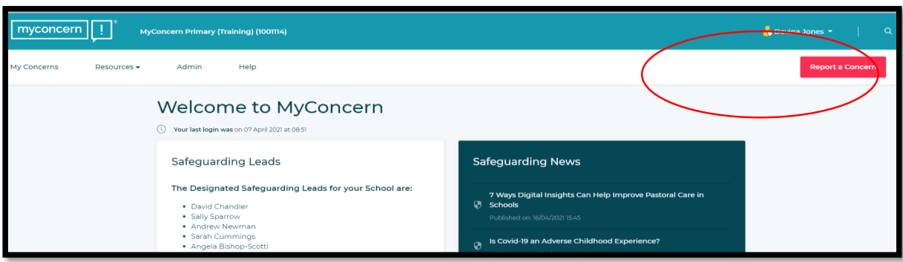
Click on the red tab. This will take you to the following page.
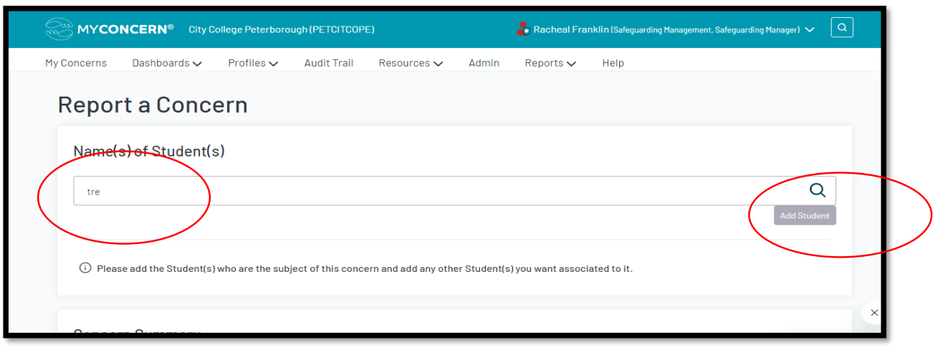
The name(s) of the learner / supported person involved can be searched here by entering the first few letters of their name. (It is important that the correct spelling is used.)
If the learner / supported person has not been entered onto the system before, their details will need to be added manually. This can be done by clicking on the ‘add student’ tab (see above)
This will open the following screen:
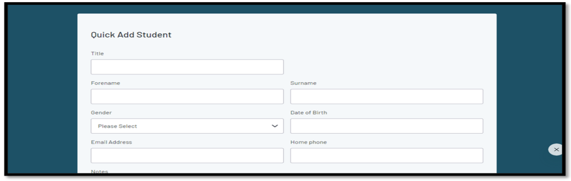
Complete the profile to include as much information as possible. This MUST include the name and date of birth as a minimum. If the date of birth is not known at this stage, please enter 01/01/2000
At the bottom of the page, there is an option to save and close (this gives you the option to return to continue logging later) or save and continue to edit. This option allows you to continue with your report.
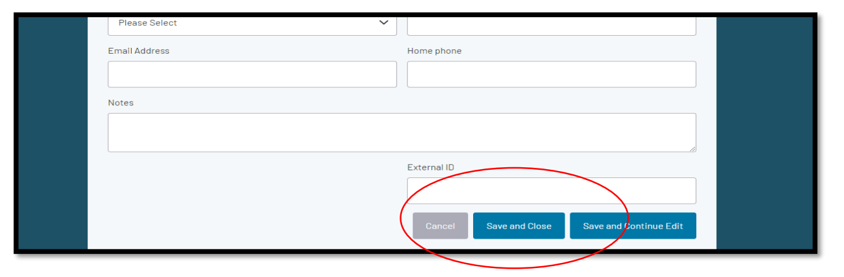
Details about the concern you are raising
Once the learner profile has been selected / added, you will have to complete the following:
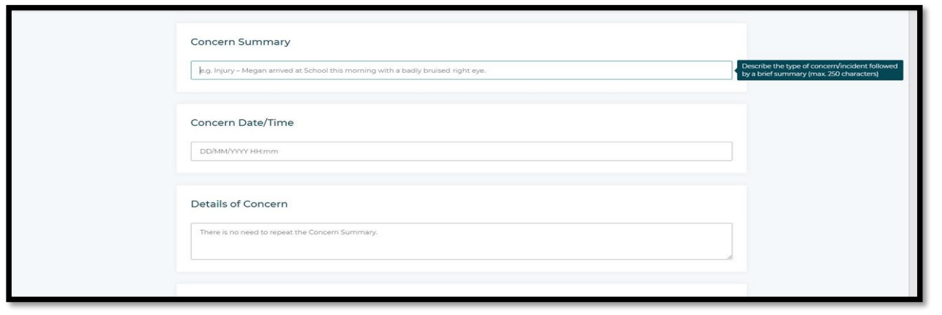
Concern summary
Describe the type of concern using a brief summary. For example – ‘Frankie attended the Industrial hub today where we noticed some bruising to his left arm.’
Concern date / time - Please ensure this is the time and date that the incident happened.
Send concern to - Please select the group responsible for managing the concern. For example, if the concern is regarding a learner at JMC, study skills should be selected, if it is an adult attending one of our day opportunity provisions, the Day Opps option should be selected. Please refrain from using the Designated Safeguarding Lead (DSL) option unless you are unsure of which group the learner belongs to. (The DSL taking ownership of a concern should update this to reflect the correct notification group if the DSL option has been selected. This ensures correct reporting figures for each area)
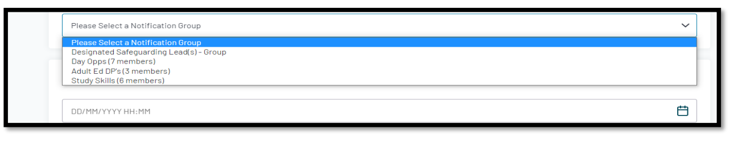
Details of concern - There is no need to repeat the concern summary. This is for any additional information such as times, people present, actual words spoken etc. For example – ‘Frankie was sat at his table holding a cup of tea. I noticed that he pulled a face and swapped his tea from one hand to the other. When I asked him if he was ok, he said his arm hurt. I asked him if I could look and he pulled up the left sleeve exposing his forearm where I saw a large bluish green bruise. I asked him how this happened, and he shrugged and said ‘it doesn’t matter.” Another staff member, Alicia was also present and heard the exchange. This is not the first time he has declined to explain why he has bruises on his person.’
Location - Use the drop-down box to choose the location where the incident / concern took place. (Please do not leave this blank)
Action taken - Please describe any action(s) you have taken or plan to take in relation to this concern. For example - ‘I called the Manager of the supported living home where Frankie lives to see if they had logged the bruising and if they had any idea of what had caused it. They advised that they didn’t have it logged’.
Supporting files - These can be uploaded as an attachment by selecting the saved file from your computer.
- Is your concern Urgent?
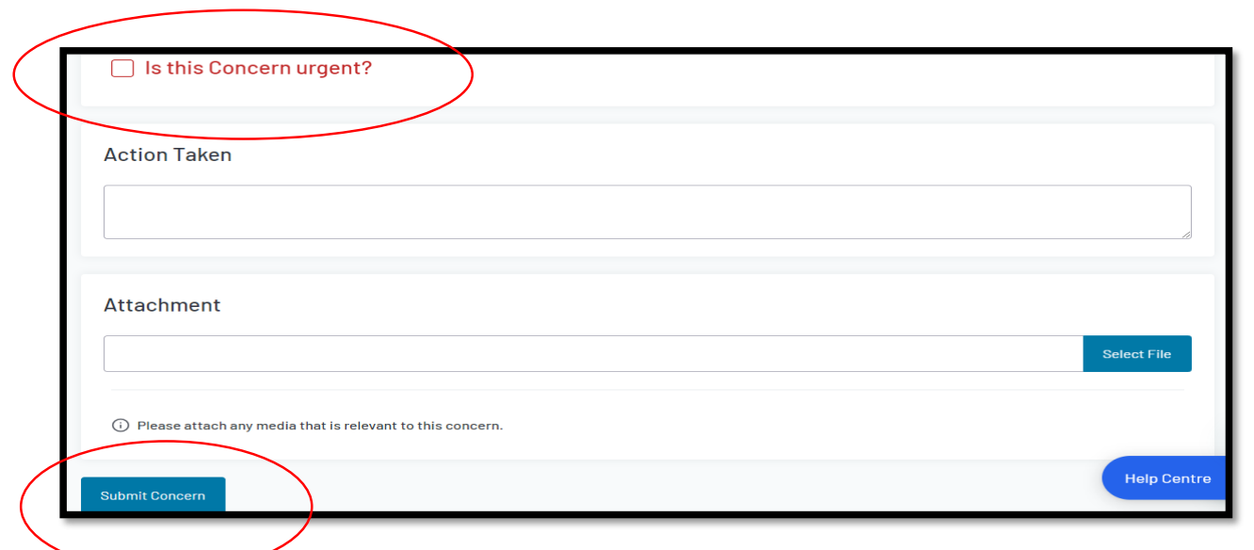
Is this concern urgent? If you feel that the concern might result in serious or immediate risk of harm to the person involved, you should tick the box marked, ‘is this concern urgent?’ as pictured above.
DPs will receive an email alert whenever a concern is recorded for their area; however, if your concern is urgent, you should contact a DP to inform them as they may not have access to their emails.
REMEMBER – if a learner or supported person is at an immediate risk of harm phone 999 and alert the Duty Manager.
Next steps
Once you are satisfied that you have provided as much information as possible and all sections are completed, please submit using the submit concern tab at the bottom left of the page. You will then see the following screen with the concern reference number.
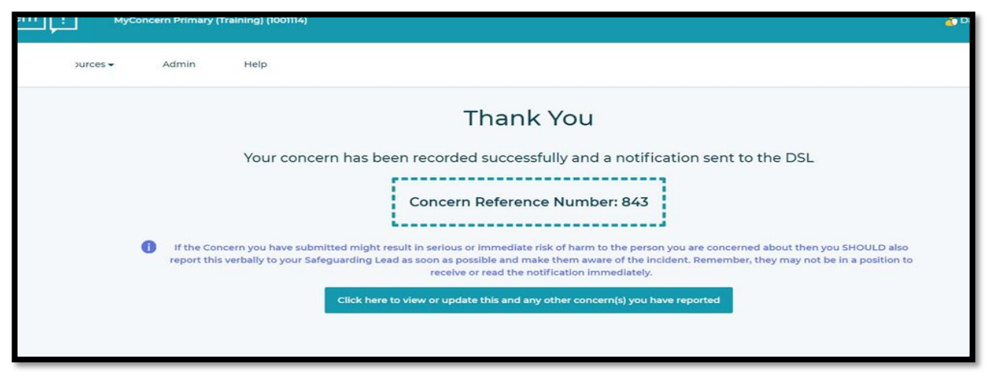
You do not need to take any further action. Your concern will be sent to the appropriate to be dealt with. Once a concern is raised it is normal procedure to not confirm with staff any action that has been taken or any ongoing investigations into the concern raised. One of the safeguarding team may need to speak with you to discuss the concern you have raised.
If you have any questions or need to debrief with a member of the safeguarding team, you can email them directly or speak with you line manager to access help and support.

Managing Allegations Against a Member of Staff
Managing allegations of abuse by members of staff must be in accordance with Keeping Children Safe in Education (DfE 2024) and Cambridge and Peterborough Safeguarding Partnership Board Allegations against Staff or Volunteers guidance.

This procedure should be applied when there is such an allegation or concern that a person who works with children, has:

- behaved in a way that has harmed a child or may have harmed a child
- possibly committed a criminal offence against or related to a child OR
- behaved in a way that indicates he / she is unsuitable to work with children.

These behaviours should be considered within the context of the four categories of abuse (i.e., physical, sexual and emotional abuse and neglect). These include concerns relating to inappropriate relationships between members of staff and children or young people, for example:
- Having a sexual relationship with a child under 18 if in a position of trust in respect of that child, even if it claimed to be consensual (see ss16-19 Sexual Offences Act 2003).
- 'Grooming', i.e., meeting a child under 16 with intent to commit a relevant offence (see s15 Sexual Offences Act 2003).
- Other 'grooming' behaviour which may not meet the criminal threshold, but gives rise to concerns of a broader child protection nature (e.g., inappropriate text / e-mail messages or images, gifts, socialising etc.); or,
- Possession of indecent photographs / pseudo-photographs of children.

  - All staff who have, or receive concerns about, the conduct of any colleague, permanent, temporary or voluntary, must report the matter immediately. Any concerns should be reported to the Designated Safeguarding Lead. If, within two hours of the initial concern arising, it has not been possible to contact the nominated member of staff, the matter must be reported to a member of the Leadership Team or the Assistant Director of People and Communities, Peterborough City Council (our Peterborough City Council Safeguarding Lead, see Appendix 2 for email address).

  - If the concern is in relation to the designated member of staff, the matter should be reported to the DSL. In the event that the concern is in relation to the DSL, that must be reported to the Assistant Director.

  - The procedures laid down in the Cambridgeshire & Peterborough Safeguarding Partnership Board along with the City College Peterborough Code of Conduct and Disciplinary Policy as appropriate.

Potential Indicators of Abuse
  - There are a number of common factors, which can be potential indicators of abuse in children, young people and vulnerable adults. It is important to remember that many of the characteristics and signs detailed can also be typical for some individuals, so whilst it is important to be vigilant in such matters, staff should also be tactful in their approach. This information is provided as a guide only and further support should be sought following the guidance in the Policy and Procedures documents where there are possible safeguarding concerns.

Potential indicators of physical abuse
- Injuries to any part of the body.
- Individuals who find it painful to walk, sit down, to move their jaws or are in some other kind of pain.
- Injuries which are not typical of the bumps and scrapes associated with regular activities e.g. injuries of an usual shape / type or with very clearly defined marks that may be the result of being hit with an object.
- The regular occurrence of unexplained injuries.
- Frequent injuries, where explanations may be confused.
- Conflicting explanations of how the injuries were sustained.
- Furtive / secretive behaviour.
- Uncharacteristic aggression or withdrawn behaviour.
- Compulsive eating or sudden loss of appetite.
- Sudden ill co-ordination.
- Difficulty staying awake.
- Wider concerns about the family / home life situation.

Potential indicators of emotional abuse
- Poor attachment relationships with children.
- Unresponsive or neglectful behaviour towards the individual’s emotional or psychological needs.
- Persistent negative comments about the individual.
- Inappropriate or inconsistent developmental expectations of the individual.
- Parental problems that supersede the needs of the child / vulnerable adult.
- Dysfunctional family relationships including domestic violence.
- Emotional indicators such as low self-esteem, unhappiness, fear, distress, anxiety.
- Behavioural indicators such as attention seeking, opposing, withdrawn, insecure.
- Physical indicators such as failure to thrive / faltering growth, delay in achieving developmental, cognitive or educational milestones.

Potential indicators of sexual abuse
- Signs of blood or other discharge on the individual’s clothes.
- Awkwardness in walking or sitting down.
- Stomach pains.
- Bed wetting.
- Tiredness.
- Extreme variations in behaviour e.g. anxiety, aggression or withdrawal.
- Sexually provocative behaviour or knowledge that is incompatible with the individual’s age and understanding.
- Drawings and or written work which are sexually explicit and inappropriate for the context of the work (indirect disclosure).
- Direct disclosure.

Potential indicators of neglect
- Abnormal growth including failure to thrive.
- Recurrent infection.
- Unkempt dirty appearance.
- Poor body hygiene.
- Inadequate / unwashed clothes.
- Hunger.
- Listlessness.
- Attachment disorders.
- Indiscriminate friendliness.
- Poor social relationships.
- Poor concentration.
- Developmental delays.
- Low self-esteem.
- Insufficient food, heating and ventilation in the home.
- Risk from animals in the household.
- Inappropriate sleeping arrangements and inadequate bedding.
- Dangerous or hazardous environment.

Potential indicators of radicalisation
There is no single way of identifying who is likely to be vulnerable to being drawn into terrorism or radicalisation. HM Government ‘Channel’ guidance indicates factors which may have a bearing on someone becoming vulnerable can include:
- Peer pressure.
- Influence from other people or via the internet.
- Bullying.
- Crime against the individual or their involvement in crime.
- Anti-social behaviour.
- Family tensions.
- Race / hate crime.
- Lack of self-esteem or identity.
- Personal or political grievances.

Assessment for vulnerability uses a consistently applied vulnerability assessment framework built around three criteria these are:
      - Engagement with a group, cause or ideology.
      - Intent to cause harm.
      - Capability to cause harm.

Potential Indicators of engagement with an extremist group, cause or ideology
- Spending increasing time in the company of other suspected extremists.
- Changing style of dress or personal appearance to accord with the group.
- Day-to-day behaviour becoming increasingly centred on an extremist ideology, group or cause.
- Loss of interest in other friends and activities not associated with the extremist ideology, group or cause.
- Possession of material or symbols associated with an extremist cause (e.g. the swastika for far-right groups).
- Attempts to recruit others to the group / cause / ideology.
- Communications with others that suggest identification with a group / cause / ideology.

Potential indicators of CCE (Child Criminal Exploitation)
CCE is where an individual or group takes advantage of an imbalance of power to coerce, control, manipulate or deceive a child into any criminal activity in exchange for something the victim needs or wants, and/or for the financial or other advantage of the perpetrator or facilitator and/or through violence or the threat of violence. Indicators include learners and people we support who:
- Appear with unexplained gifts or new possessions.
- Associate with other young people involved in exploitation.
- Suffer from changes in emotional well-being.
- Misuse drugs and alcohol.
- Go missing for periods of time or regularly come home late.
- Regularly miss school or education or do not take part in education.

Potential indicators of CSE (Child Sexual Exploitation)
CSE occurs where an individual or group takes advantage of an imbalance of power to coerce, manipulate or deceive a child into sexual activity in exchange for something the victim needs or wants, and/or for the financial advantage or increased status of the perpetrator or facilitator. In addition to the above indicators of CCE, indicators of CSE can be learners and people we support who have older boyfriends or girlfriends and who suffer from sexually transmitted infections or become pregnant.

  - Child-on-child abuse
Child-on-child abuse is a specific form of abuse, that whilst covered within the categories outlined in the policy and procedures, requires a specific focus within the college as it is recognised that it is a particularly sensitive and complex area of safeguarding learners and people we support within the College.

All staff should recognise that learners and people we support are capable of abusing their peers and that inappropriate behaviour should never be tolerated or passed off as ‘banter’ or ‘part of growing up’.

Child on child abuse is often gender specific, such as girls being inappropriately touched or sexually abused by boys; boys may be more vulnerable to initiation or hazing type violence and rituals.

Types of child-on-child abuse include:
- Physical abuse such as:
  - Biting
  - Kicking
  - Hitting
  - Hair pulling.
- Sexually harmful behaviour such as:
  - Inappropriate language
  - Touching
  - Sexual assault.
- Bullying, which can be:
  - Physical
  - Name calling
  - Homophobic etc.
- Cyberbullying.
- Sexting (also known as youth produced sexual imagery).
- Initiation / hazing.
- Prejudiced behaviour.
- Teenage relationship abuse.
- Up-skirting.

Expected response from staff
It is important to deal with a situation of peer abuse immediately and sensitively. As with any safeguarding concern, it is important to gather the information as soon as possible to ascertain the true facts. This should be done objectively, with consideration of intent. Where it is deemed that any party involved in the child-on-child abuse is at risk, then a safeguarding referral should be made. Where there is a potential criminal act, the police should also be informed.

Dealing with sexting (or youth produced sexual imagery)
The college will make reference to the UK Council for Internet Safety guidance when dealing with incidents of sexting. All incidents of sexting should be initially dealt with as a safeguarding concern, and the College will be guided by the principle of proportionality and the primary concern at all times will be the welfare and protection of the young people involved.
The incident will be referred to the police and/or social care immediately if:
- The incident involved an adult.
- There is reason to believe the young person is being coerced, blackmailed or groomed, or there are concerns about their capacity to consent.
- The imagery suggests sexual acts that are unusual for the young person’s developmental stage or are violent.
- The imagery involved sexual acts and any young person under the age of 13 (i.e., below the age of legal consent); or,
- There is reason to believe a young person is at immediate risk of harm owing to the sharing of the imagery, for example the young person is presenting as self-harming.

The DSL should be notified as soon as is practicable of the referral if they have not been involved in the original decision to refer.

If none of the above apply, the usual safeguarding process should be applied.

  - Online Safety
Due to an increase in online learning, it is essential that learners and people we support are safeguarded from potentially harmful and inappropriate online material. The College is committed to supporting online safety and deploys Smoothwall which highlights any irregular or inappropriate use of online material whilst using the college IT system and devices. Additionally, any safeguarding concerns that are identified by staff when online should be reported in the same manner and urgency, using City College Peterborough Safeguarding Procedures.

Staff should ensure that they adhere to the guidance regarding Online Safeguarding Processes applicable to all online learning, support and communication with learners and people we support. A specific Online Safety and Behaviour Contract should be reinforced by all staff to learners and people we support when engaging online or remotely.

City College Peterborough has robust filtering and monitoring systems installed on all college owned devices. Any breaches to the online safety standards should be referred through the usual safeguarding process.

All IT users who access our buildings, technology and networks (including remotely) have a role in ensuring that safety is embedded within the organisation. All staff must sign a declaration to say they will adhere to the Acceptable Use of Technology Policy. Learners and people we support are asked to sign an acceptable use document before taking equipment out on loan. People using our computers whilst on site will be given a link to the acceptable use document and asked to click to agree to it before they can successfully log on.

APPENDIX 2
- City College Peterborough Safeguarding contacts & external links

Role | Name | email
Peterborough City Council Safeguarding Lead | Ingrid Hooley | ingrid.hooley@peterborough.gov.uk
Designated Safeguarding Lead | Tasha Dalton | tdalton@citycollegepeterborough.ac.uk
Deputy Designated Safeguarding Lead | Sarah Perkins | sperkins@citycollegepeterborough.ac.uk
Deputy Designated Safeguarding Lead | Michaela Granger | mgranger@citycollegepeterborough.ac.uk
Deputy Designated Safeguarding Lead | Barry Spicer | bspicer@citycollegepeterborough.ac.uk
A full and up-to-date list of the safeguarding team can be found on the college intranet and information boards around the college campuses and sites.

1.2 Additional Lead Responsibilities:

Role | Name | Email
Prevent incl. SPOC | Barry Spicer | bspicer@citycollegepeterborough.org.uk
Domestic Violence | Helen Stimson | hstimson@citycollegepeterborough.ac.uk
Child Sexual Exploitation | Michaela Granger | mgranger@citycollegepeterborough.ac.uk
Online Safety | Barry Spicer | bspicer@citycollegepeterborough.org.uk
Across the City College Peterborough Safeguarding team staff are trained in a variety of areas such as Peer-on-Peer abuse, FGM, forced marriage and Early Help assessment this is not an exhaustive list.

Every interview panel at City College Peterborough has a minimum of one member of staff who is safer recruitment trained.

1.3 City College Peterborough helpful contact details:

Location | Availability | Contact details
College duty manager | Term time:  8.45 – 9pm Mon – Tuesday  8.45 – 6pm Thur & Fri  Non term time:  8.45 – 6pm daily
Brook Street campus | Term time:  Monday – Wednesday - 8.30am – 7pm  Thursday – 8.30am – 5pm  Friday – 8.30am – 4.45pm  Non term time:  Monday – Thursday - 8.30am – 5pm  Friday – 8.30am – 4.45pm | 01733 761 361  Reception 248
John Mansfield campus | Monday to Friday  8.45 – 6pm | 01733 761361 Reception Ext 800
Kingfisher Centre | 9am – 4pm Mon - Fri | 01733 797 728
Industrial Hub | 8am – 3:30pm Mon - Fri | 01733 797701
City Centre Hub | 9am – 4pm Mon - Fri | 01733 588 356
Skills development hub | 9am – 4pm Mon - Fri | 01733 797 723
Out of hours support. Any safeguarding concern that has been raised during college hours will be assigned to staff who will ensure support is available, even if this is out of hours. Any Safeguarding concerns that happen outside of college hours should be reported to the relevant authority in the first instance and college staff will provide appropriate support from the point of referral.

1.4 Other information and sources of information

Cambridgeshire and Peterborough Safeguarding Children Partnership Board.

The Cambridgeshire and Peterborough Safeguarding Partnership Board (Cambridgeshire County Council, Peterborough City Council, Cambridgeshire Constabulary and the Cambridgeshire and Peterborough Integrated Care Board), are responsible for ensuring that children, young people and adults at risk of harm, neglect and exploitation across Cambridgeshire and Peterborough receive the help and protection that they need. The site contains resources, tools and contact information.

Cambridgeshire & Peterborough Safeguarding Partnership Board (safeguardingcambspeterborough.org.uk)

Agency | Number | Email
Police Child Abuse Investigation Unit | Tel: 101/999
Early Help | 01733 863649 | helpwithcaf@peterborough.gov.uk
Customer Service Centre – social care referrals | 01733 864180
Emergency Duty Team (Out of hours) | 01733 234724
Local Authority Designated Officer (LADO) | 01733 864038 | LADO@peterborough.gov.uk
PREVENT Team | 01480 422596 | prevent@cambs.nn.police.uk
Customer Services – Adult social care | 01733 747474 (9am to 5pm Monday to Friday) | adultsocialcare@peterborough.gcsx.gov.uk

APPENDIX 3 – REFERENCES & MONITORING

- Local procedures & guidance

Peterborough and Cambridge Safeguarding Board Multi Agency Policies and Procedures

- City College Peterborough / Peterborough City Council Related Documents

Anti Bullying and Harassment Policy including behaviours of concern
Modern slavery
Equality and Diversity
Conflict resolution and physical intervention policy
Learner disciplinary and behaviour policy
Online Safety Policies including acceptable use of technology and bring your own device
Sexual violence, harassment and bullying policy
Data protection
Code of conduct & Disciplinary policy
Visitors and Contractors and Lone Workers Policy
Whistleblowing Policy
External Speakers Policy

Policies can be found on the college intranet.

National Guidance

Keeping Children Safe in Education 2025
Working together to Safeguard Children (2023)
Sharing nudes and semi-nudes: advice for education settings working with children and young people (2020)
NPCC Whistle blowing
Preventing and Tackling Bullying, DfE (2017)
Prevent Duty guidance for further education revised (2021)
Meeting digital and technology standards in schools and colleges, Filtering and monitoring standards for schools and colleges” (2023)

The effectiveness of this policy will be monitored and measured in a variety of ways. These will include:

- Regular reporting on safeguarding incidents to the Advisory Board.
- Measuring staff confidence in managing safeguarding incidents.
- Individual training and development records.
- Using surveys to measure how satisfied learners and supported people are with our safeguarding provision.
- Feedback from partners on quality and appropriateness of referral.

