Anti-Bullying and Harassment Policy

Position Statement

The College recognises its responsibility to provide an environment free from bullying and harassment and upholds the rights of employees, learners, supported people and other building-users to be treated with dignity and respect. In line with our Equality and Diversity Policy, the College expect standards of behaviour that reflect this and regards any form of harassment, victimisation, intimidation or bullying as unacceptable behaviour.

Scope

It is the responsibility of all employees, learners, supported people and other building-users to follow the principles of this policy, treating others with respect and avoiding any form of discrimination.

Responsibilities

Groups with additional responsibilities for implementation, monitoring and reporting include the Governing Board, Senior Leadership Team, Equality and Diversity Task Group, Safeguarding Task Group and the Quality department.

Definitions

Bullying

City College Peterborough adopts the Peterborough City Council’s definition of Bullying as outlined in the Grievance Procedure:

Bullying may be characterised as offensive, intimidating, malicious or insulting behaviour, an abuse or misuse of power which is meant to undermine, humiliate or injure the person on the receiving end.

Power does not always mean being in a position of authority and can include both personal strength and the power to coerce through fear or intimidation.

Bullying make take the form of physical, verbal and nonverbal conduct and may include for example picking on someone or setting a person up to fail or making threats or comments about someone's job security without good reason.

Digital bullying can include but is not limited to cyber bullying, online bullying (sexualised or otherwise), skin gambling, blackmail and teenage dating apps.

Legitimate, reasonable and constructive criticism of an employee’s performance or behaviour or reasonable instructions given to workers in the course of their employment will not amount to bullying on their own.

A single incident can be bullying if it is sufficiently serious.

The College recognises that peer on peer abuse can manifest itself in many ways. This can include but is not limited to bullying, cyberbullying, sexual violence, sexual harassment, being coerced to send sexual images (sexting), teenage relationship abuse, physical abuse and up-skirting. For further information, see the Safeguarding and Child Protection Policy for Children and Vulnerable Adults.

Anybody can be the victim of bullying, but groups that are particularly vulnerable are people with Special Education Needs and Disabilities and young people with family members in prison.

Harassment

Harassment is a form of discrimination that can be defined as any action or practise by a person or group of people which is directed at an individual and is unwanted and causes humiliation, offence and distress.

According to the law, harassment is illegal behaviour towards a person that causes mental or emotional suffering, which includes repeated unwanted contacts without a reasonable purpose, insults, threats, touching, or offensive language

For further information, the CCP Equality and Diversity Policy lists the protected characteristics under the Equality Act 2010.

Examples of bullying and harassing behaviour:

- name-calling or other derogatory remarks including lewd comments about appearance
- threatening words or behaviour
- punching, pushing or other forms of unnecessary body contact
- displaying abusive writing or pictures
- coercing someone into hand over money, mobile phone or other possessions
- sending abusive or threatening text messages, emails or other postings on social networking sites such as Facebook, Twitter and Myspace
- spreading rumours about someone
- ignoring or excluding an individual or group
- public humiliation or criticism
- withholding necessary information
- substituting responsible tasks with menial or trivial ones

Policy

It is the policy of City College Peterborough that:

- It will not tolerate any form of bullying or harassment.
- All staff, learners, supported people are responsible for making sure the College is free of bullying.
- Any person alleging bullying will be provided with help and support through the process and will be protected from victimisation.
- The College will adopt a procedure for challenging bullying or harassing behaviours which will enable staff to effectively intervene in an appropriate way. This may include, but is not limited to, using the Challenging Behaviour Policy, Learner Disciplinary Policy or PCC Disciplinary Policy (for employees). In instances where inappropriate behaviour is the result of a disability, staff will work to minimise the impact by working through support plans and behaviour support plans to keep affected people apart as appropriate.
- Any complaints of bullying or harassment will be investigated quickly, effectively and sensitively. Complaints may result in disciplinary action and could lead to expulsion or dismissal (of employees).
- False allegations of bullying or harassment will be taken seriously, and further action may be considered.
- The College will be proactive in promoting the Anti-Bullying and Harassment Policy.

Reporting concerns

We will not set a limit to the way in which a concern can be raised but would encourage one of the following actions:

- Complete a Discrimination, Harassment or Bullying Reporting card – found as an appendix to this policy and also towards the back of the learner handbook (learners and supported people).
- Go and speak to somebody with a Bee symbol on their door.
- Ask to speak to a Designated Safeguarding Person.
- Fill in a Feedback form. You can ask a tutor or other member of staff for a form (e.g. by going to reception). Forms are also available on the college website under Student Info – Have your say – Complaint Procedure.
- Speak to a member of staff – they will be able to help you with any of the steps above.
- If employees do not feel that they can talk to their line manager informally, raise a grievance. The Grievance Procedure is available on the Staff Handbook area of SharePoint.

Implementation

Employees, learners and supported people (were appropriate) will be made aware of this policy through induction and information online. Employees will be given training via Safeguarding training and the reporting system – MyConcern.

9Linked documents

CCP Equality and Diversity Policy
CCP Challenging Behaviour Policy
CCP Learner Disciplinary Policy
CCP Learner Handbook
CCP Safeguarding Policy
CCP Online Safety Policy
PCC Code of Conduct (employees)
PCC Grievance Procedure (employees)
PCC Disciplinary Policy (employees)

Monitoring and Impact Assessment

This policy will be reviewed annually but may be revised throughout the year in the event that new legislation or guidance comes into effect.

Impact Assessment approved by the Equality and Diversity Task Group on 23/12/2019

Latest Governing Board Approval Date: 02/07/20

Appendix
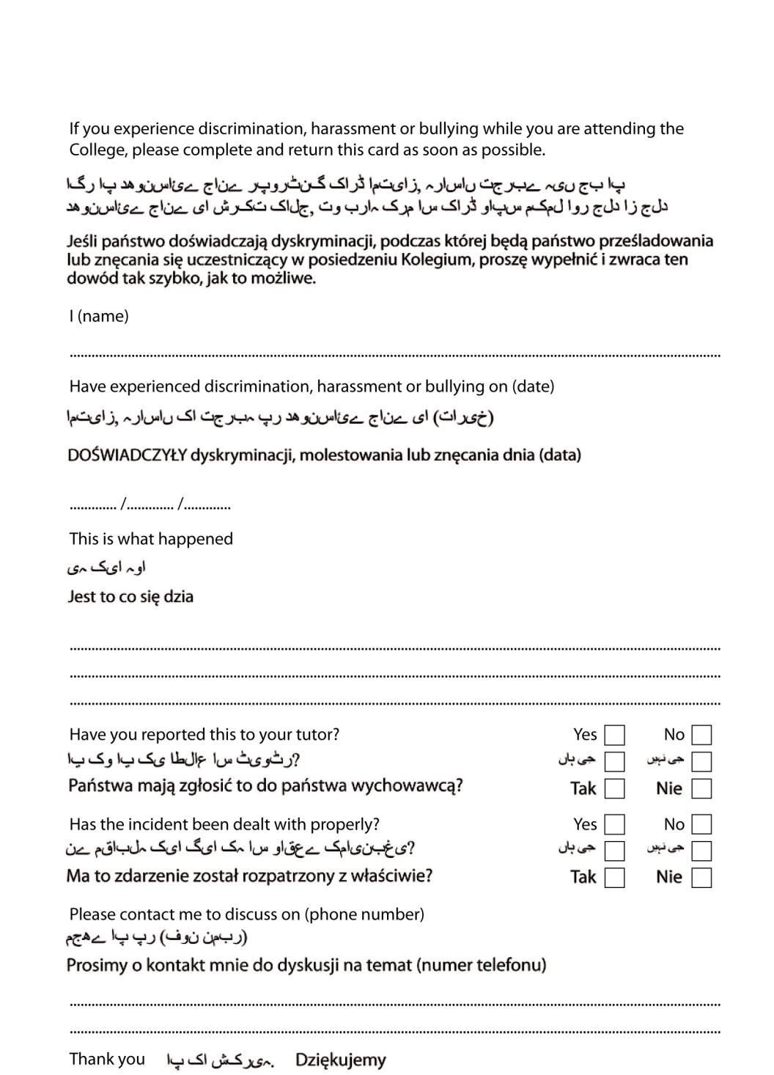
DISCRIMINATION, HARASSMENT OR BULLYING REPORTING CARD

